
By entering the Sheringham Wildlife Garden Awards, you’re not only helping local wildlife, but you’re also inspiring others to do the same.
This scheme is about celebrating progress, not perfection, so share your green space with us, show us what you’re doing and let’s grow a wilder, greener Sheringham together.
Organisation | (If applicable)
Name
Address | (Optional)
Telephone
Email
Address | (Optional)
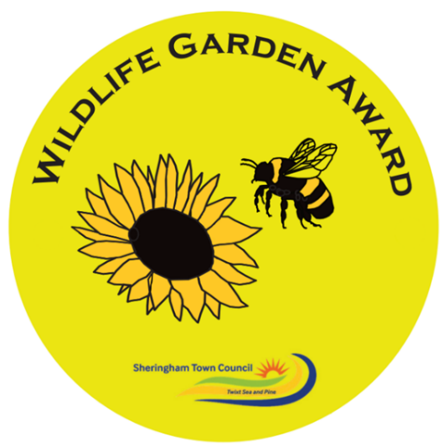
Please tick all the boxes that apply to your garden:
Do you provide FOOD?
☐Bird feeder cleaned regularly
☐Native plants/wildflowers e.g. nettle, garlic mustard for caterpillars etc
☐Nectar rich plants for pollinators e.g. open type flowers
☐Berry/fruit/flowering shrubs
☐Edible seedheads e.g. sunflowers
☐Hedgehog food
☐Other:
Do you provide SHELTER?
☐Bird box
☐Bug hotel
☐Hedgehog house
☐Bee hotel
☐Bat box
☐Log or rock pile
☐Mature trees
☐Long grass/untidy corners/plant stems to overwinter
☐Leaf piles
☐Climbers e.g. ivy
☐Other:
Do you provide WATER?
☐Bird bath cleaned regularly
☐Wildlife pond
☐Water butt/grey water recycling
☐Ground level water dish for hedgehogs
☐Water dish for insects
☐Bog area
☐Other:

Do you provide CONNECTIVITY?
☐Hedges/trees connecting to other gardens esp native species
☐Hedgehog holes
☐Collaboration with neighbours on nature corridors
☐Plants growing up and over walls/fences
☐Connecting with other people e.g. elders, children on wildlife matters
☐Sharing wildlife ideas with others e.g. social media, neighbours, groups
☐Telling at least 5 other people about the Sheringham Wildlife Garden Awards
☐Other:
How do you MANAGE your garden?
☐No chemicals e.g. pesticides, slug pellets etc, use companion planting
☐Recycling garden waste e.g. compost, wormery
☐Recycling garden objects e.g. old sink for pond
☐Peat-free compost
☐Growing from seeds/cuttings/plant swaps to reduce carbon footprint
☐Be Organic
☐Drought resistant plants
☐Lawn or part of left uncut for wildflowers
☐Encourage beneficial insects e.g. ladybirds, hoverflies
☐Stems left uncut over winter
☐Hedges etc left uncut 1st March to 31st August
☐Pond made safe for wildlife e.g. ramp to escape/shallow sides
☐Watering cans and butts kept covered to stop wildlife drowning
☐Other:
Please list any other actions you have taken to help wildlife:
Let us know the SIZE of your garden / green space
☐Large (football pitch +)
☐Medium (tennis court +)
☐Small
☐Allotment
☐ Balcony
☐Other: Please specify e.g. window box/courtyard/community garden
Remember entry is to join this scheme is FREE and open to everyone in Sheringham doing their bit for nature. Once you have filled out this checklist, take some photos of your garden / green space and send this information to:
Edie.jolley@sheringhamtowncouncil.gov.uk
Your garden will be assessed using our checklist and the photos you send through to us, no visits required!
The more wildlife-friendly features you tick off (based on your garden size), the higher your award level and you will receive a certificate to recognise your efforts and a plaque to proudly display.
Categories of award

- Gold = 30 ticks with at least 6 from each category
- Silver = 20 ticks with at least 4 from each category
- Bronze = 10 ticks with at least 2 from each category
- Balcony = 8 ticks with one in each category
- Window box = 5 ticks with at least 1 from each category

